Test case 1: “” nothing added
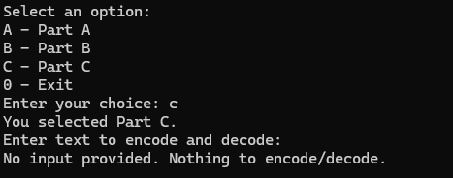

Test case 2: “A”
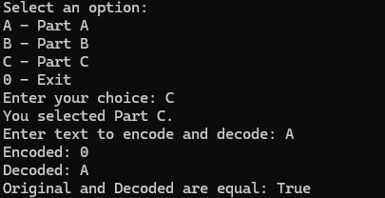
Test case 3: “AAAAAAAAAAAAAA”
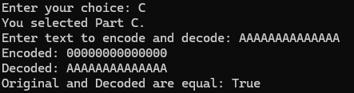
Test case 4: “BBBBBBBBBBBBBA”
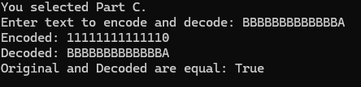

Test case 5: “ABABABABABABABAB”
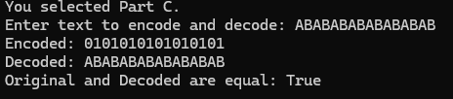
Test case 6: “12345”
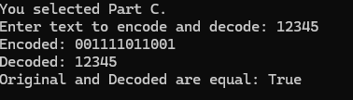
Test case 7: “321as$$##@”
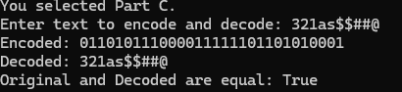
Test case 8: “!@#$%”
